**Results of Experiments**

**A pathologies : ['IAVB', 'AF', 'LBBB', 'PAC', 'RBBB', 'SNR']**

**AB pathologies : ['AF', 'AFL', 'Brady', 'CRBBB', 'IAVB', 'IRBBB', 'LBBB', 'PAC', 'PVC', 'RBBB', 'SB', 'SNR', 'STach', 'SVPB']**

**ABE pathologies : ['AF', 'AFL', 'Brady', 'CRBBB', 'IAVB','IRBBB', 'LAnFB', 'LAD', 'LBBB', 'LQRSV', 'NSIVCB', 'PR', 'PAC', 'PVC', 'LPR', 'LQT', 'QAb', 'RAD', 'RBBB', 'SA', 'SB', 'SNR', 'STach', 'SVPB', 'TAb', 'TInv']**

**On DataBase A :**

**Test Set : RBBB 319 SNR 222 AF 219 IAVB 141 PAC 107 LBBB 38**

* With A pathologies without feature Selection:
  + 0.8459817400054095,+/-,0.01694587029635966 validation set
  + 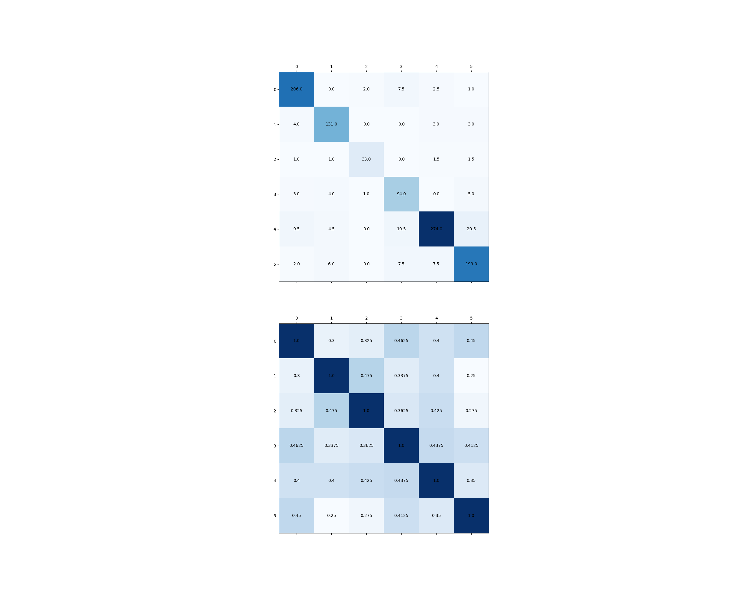0.87 Test Set
* With A pathologies with feature Selection:
  + 0.8671729448760098,+/-,0.017009566231101638 validation set
  + 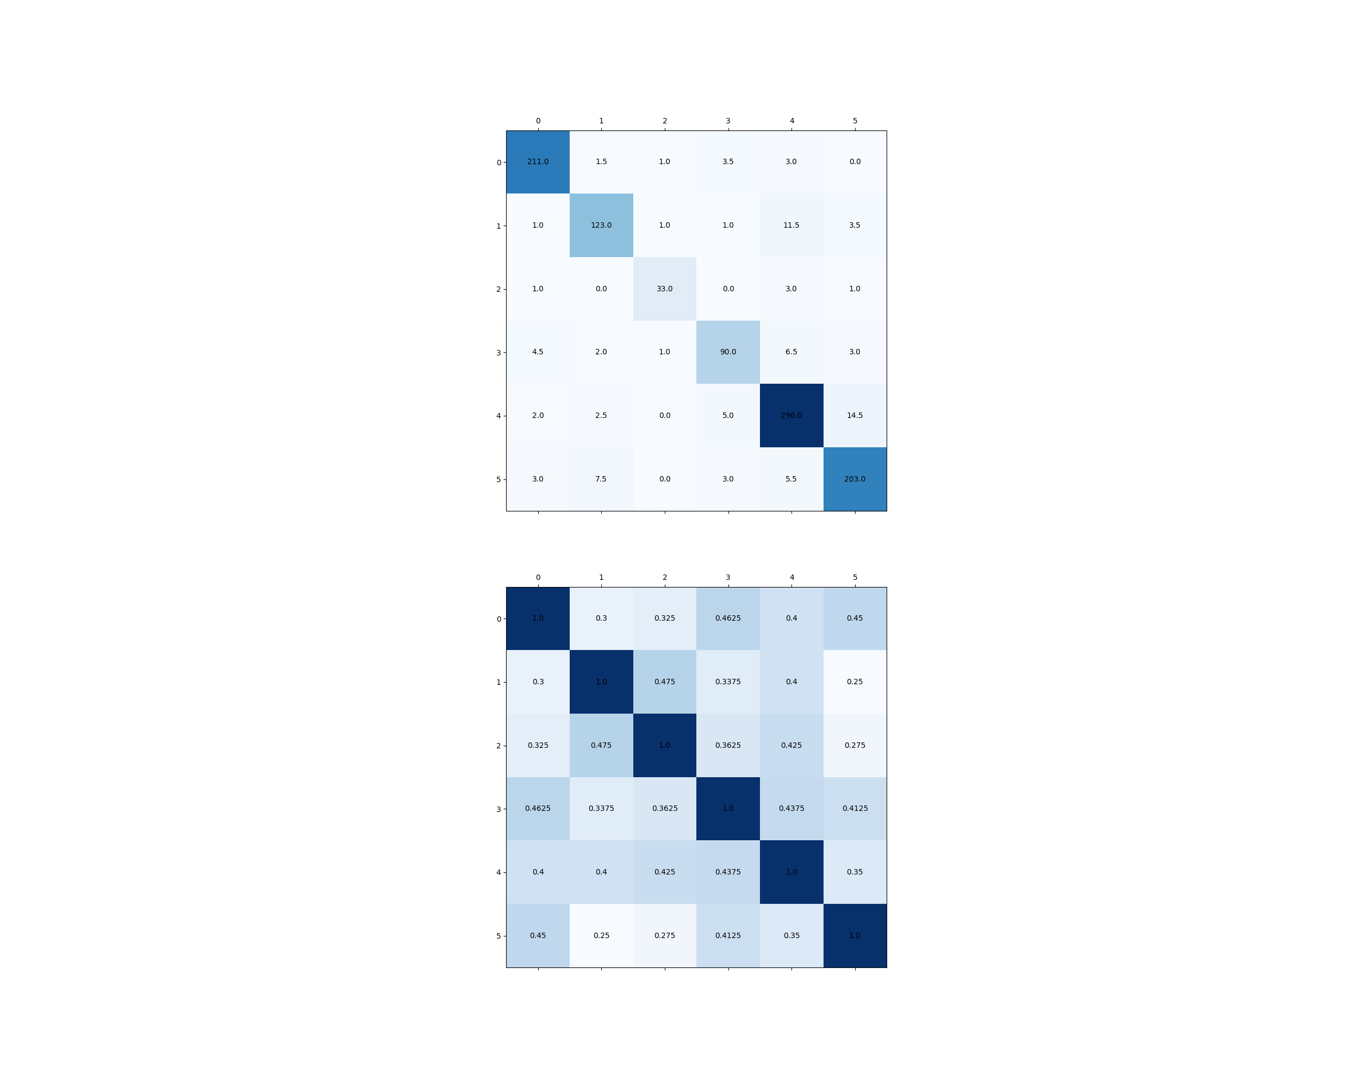0.89 test set

**On DataBase AB:**

**Test Set: RBBB 1600 AF 1136 SNR 916 IAVB 792 PAC 580 LBBB 195**

* With A pathologies without feature selection: